# Screenshots

Screenshot 1

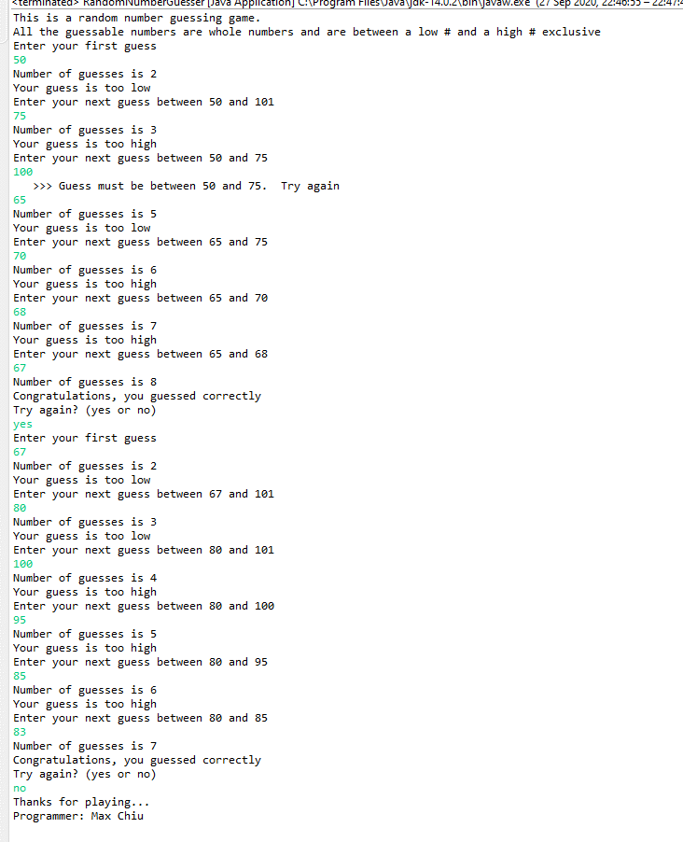

Screenshot 2

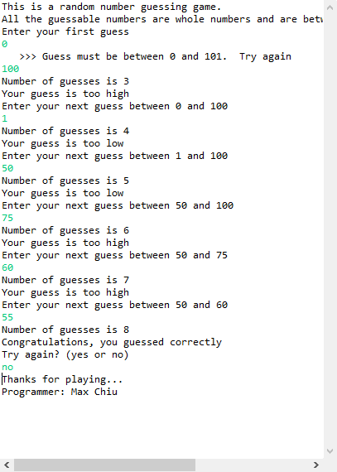

Screenshot 3

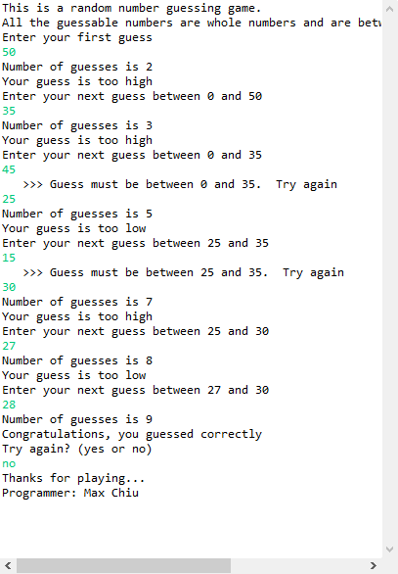

Github screenshot

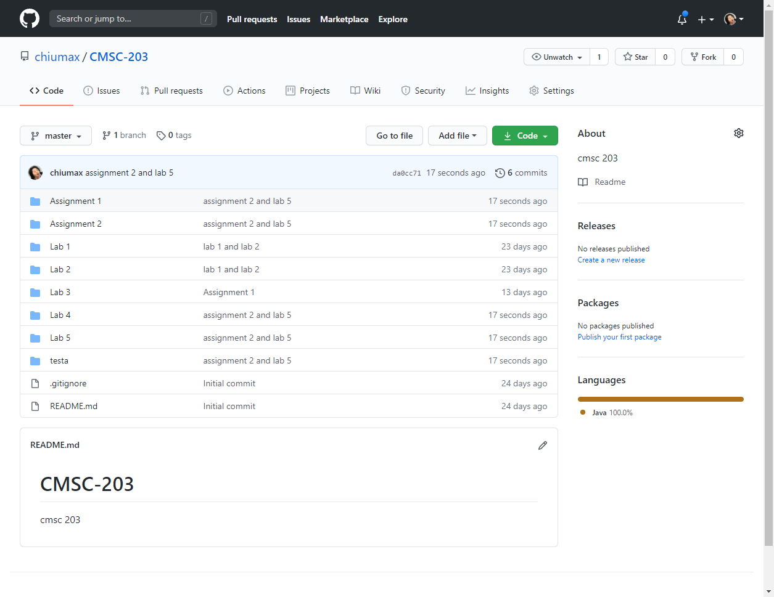

# Lessons Learned

|  |
| --- |
| * experience from working on this project. What have you learned?   I have not learned anything |
| * What did you struggle with? What would you do differently on your next project?   I did not struggle with anything |
| * What parts of the project were you successful at, and what parts (if any) you were not successful at.   I was successful at following directions. However, I was not successful at 100% following the directions as it was impossible for me to manage “count” while validating incorrect guesses as validating a guess increases the count on RNG. The screenshots do not reflect this behavior. Even if validating a guess increases the count on RNG, there are no methods that allow the programmer to reset the count after an incorrect validation. In addition to this, the instructions are inconsistent with the range of the number.  For printing, my initial end points are |

0 and 101 instead of 1 and 100 because inputValidation is exclusive

In addition to this, randNum is inclusive between 1 and 100